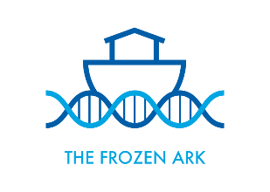

Trustee Recruitment Information Pack

About Us
The Frozen Ark is a UK based charity whose vision is to conserve the genetic heritage of endangered animals, both wild and domestic species, before they are irretrievably lost. Led by a group of ambitious Trustees, the Frozen Ark seeks to secure this heritage by collecting and conserving genetic material of endangered animals and providing coordination, infrastructure and advice on managing and maintaining these materials through working with UK and international partners.
The Frozen Ark was set up in 2004 and whilst the charity has remained relatively small, operating through donations and grants as well as in-kind backing from partners, it has an expert and well-connected Board of Trustees, part-time staff and committed volunteers. All bring a range of scientific expertise and contacts throughout the sector.
The charity has recently developed a new Business Plan and is implementing this plan to develop itself into a resilient organisation, with the support and goodwill of Trustees, partners and volunteers. To help us achieve our ambitious goals, we are looking for Trustees to join us for a three- year term, which has the potential to extend for a further two terms.
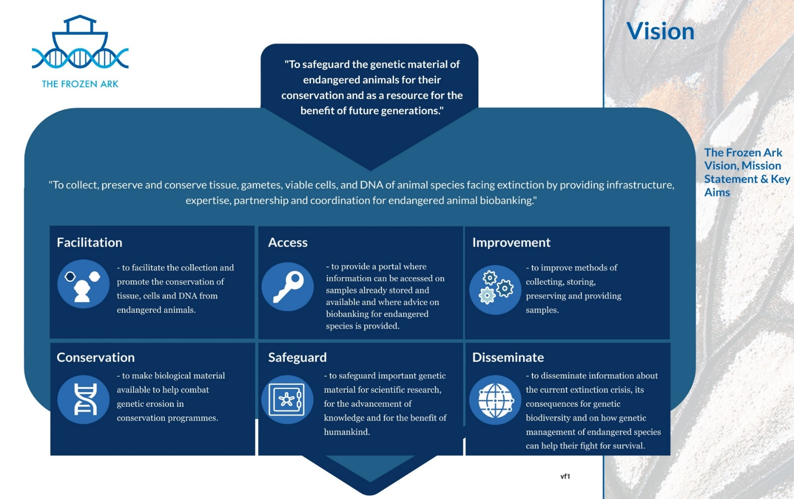

Role Title We are looking to recruit Trustees with expertise in Finance, Business, Legal and IT
Contract type Part-time, Volunteer
Term An initial term of three years, with the potential for a further two terms

Location Home based – must be able to take part in Board meetings either face to face or remotely. Board meetings take place on-line and on occasion in London, Nottingham and Cardiff.

Purpose
Trustees are responsible for the overall governance and strategic direction of the Frozen Ark and are ambassadors for the Charity, ensuring that the Ark’s activities conserve the genetic heritage of endangered animals. The Frozen Ark currently has 8 Trustees, who are also Directors.

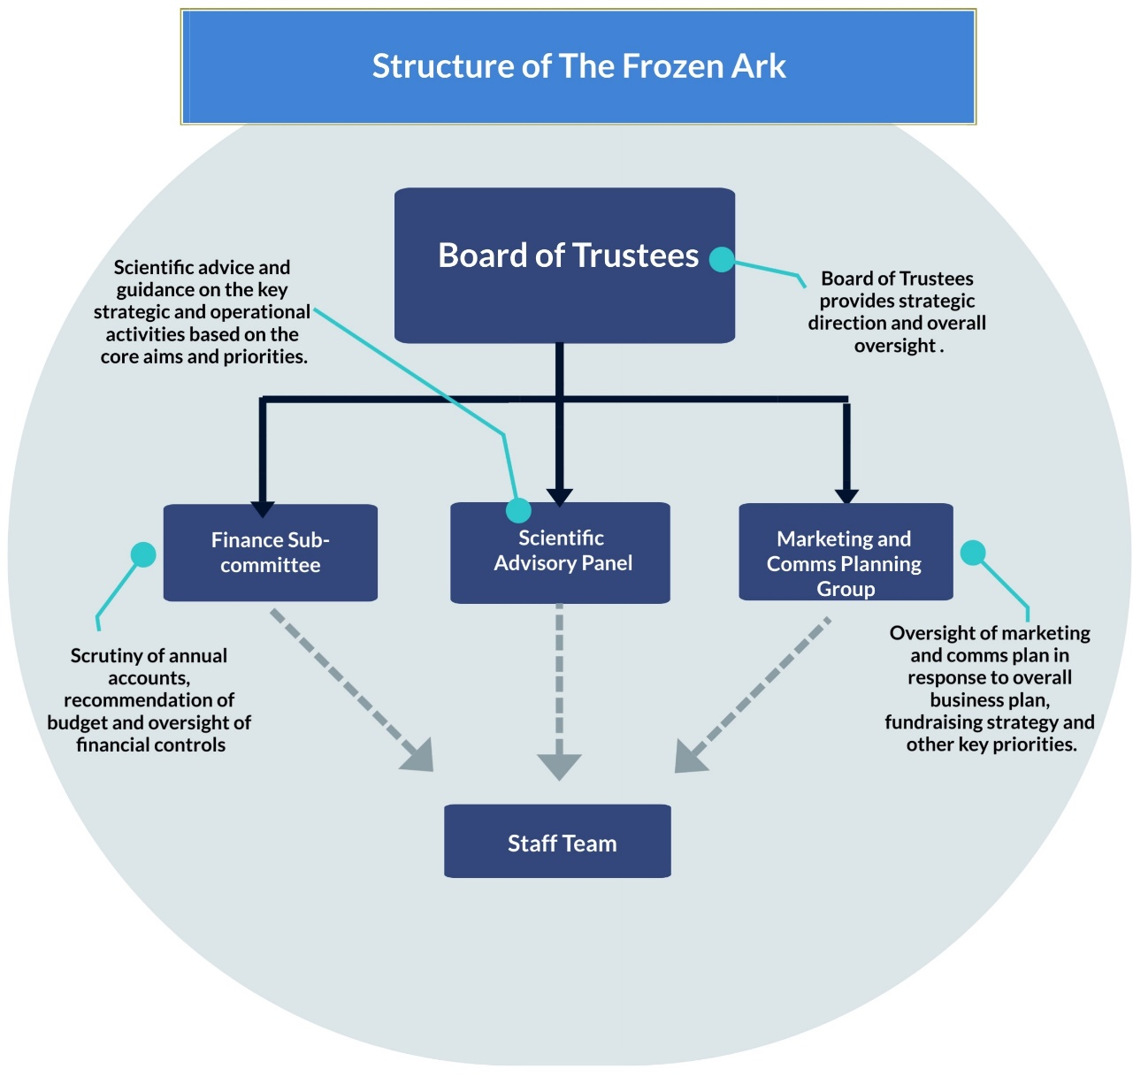

Together, the Frozen Ark Board of Trustees:
- Determines and promotes the Charity’s overall direction, strategy and vision in line with its charitable objectives.
- Ensures that the Charity complies with its governing document, charity law, company law and any other relevant legislation and regulatory requirements.
- Approves the annual budget, ensuring the Charity’s funds are used responsibly and that strong systems of financial accountability exist to safeguard long-term financial health.
- Regularly reviews major risks and ensures these are managed and mitigated effectively.
- Takes decisions that are in the best long-term interests of the Charity as a whole.
- Manages, reviews and develops the Charity’s governance and is committed to maximising the effectiveness of the Board.
- Appoints the Staff Team, ensuring that they are well supported, subject to appropriate scrutiny, and held to account in a constructive manner.

Individually, we expect our Trustees to:
- Engage fully with the work of the Board, accept and stand by the decisions made by the Board, and maintain absolute confidentiality about the Board’s work and discussions.
- Attend all Board meetings, either in person or remotely, and participate fully in relevant sub committees as appropriate.
- Support the Board and the Staff Team to be effective by being a critical friend, providing expert opinion, information, and analysis to aid decision making.
- Contribute to Board discussions and be a source of advice for other Trustees on matters related to key areas of expertise.
- Avoid any personal conflicts of interest and declare these as soon as they become apparent.
- Are accountable to the Charity’s beneficiaries, the Charity Commission, and Companies House (as company Directors).

What you’ll bring:

Essential
- Strong and visible passion and commitment to the Frozen Ark’s cause and strategic objectives.
- Willingness to devote the necessary time and effort to be an effective Trustee.
- Ability to think logically and objectively in order to identify key issues, with the confidence to make balanced and independent judgements and support robust decision making.
- An open and engaging approach to acting as a member of a team of trustees, demonstrating tact, diplomacy, honesty and integrity at all times.
- Knowledge and understanding of how charities work, including the legal duties and responsibilities of trusteeship, and an understanding of the skills and attributes demonstrated by good trustees or a willingness to proactively develop this.
  - Finance Trustee – professional finance or accountancy qualification, expertise in understanding, analysing and advising on strategy and risk.
  - Business/Commercial Trustee – recent experience in a strategic or leadership role in the development of specialist knowledge based services.
  - Social Media/Campaigning Trustee - recent experience in a campaigning role, ideally linked to conservation.

Desirable
- Experience of working with or as part of a Board of Trustees or Board of Governors is not essential, but transferrable skills form wider experience would be helpful.
- Experience of working in or as part of the conservation sector.
- Up-to-date IT and digital skills to facilitate collaborative and remote working.
- Interest in supporting and extending the Charity’s fundraising efforts and to use personal and professional networks to raise the profile.

A bit more about the role of Frozen Ark Trustees
Trustees are asked to commit an average of 1-day per month to the role. The regular annual commitment includes:
- Four meetings of the Board which are usually held during the daytime on working days. Board papers are issued 7 days in advance and Trustees need to ensure they have read and understood all information in advance of the meetings in order to fully participate and execute their duties.
- One Board away day, usually coinciding with the autumn board meeting.
- If involved in any of the sub- committees, no less than 2 meetings a year which may be held face to face or remotely.
- Additional and ad-hoc meetings with the Staff Team that might be helpful to both parties, and/or attendance at fundraising events where possible.

You will be based at home and reimbursed for reasonable expenses incurred when undertaking your role as Trustee. The role is voluntary and unremunerated.

Qualifying Criteria
All Trustees must be aged 18 or over upon appointment. The Charities Act 2011 disqualifies people who:
- Have unspent convictions for offences involving deception or dishonesty
- Are undischarged bankrupts
- Have been at any time removed from Trusteeship of a charity by the Charity Commission or the court because of misconduct
- Are disqualified from being company directors

Diversity
We hope to receive applications from a wide range of candidates from diverse backgrounds. We are looking for a mix of great people who are dynamic individuals, original thinkers, and experts in their field.

Further information
It may be possible for candidates to speak with the Chair or one of our existing Trustees in advance of applying. Please send an email to the address given below providing a brief summary bio, indicating the role you are interested in, and what you would like to discuss.

How to apply
To apply, please send us your CV and a supporting statement explaining why you want to support the conservation of the genetic heritage of endangered animals and how your skills, expertise and qualities will make you a great Trustee.

Applications should be emailed to judesmith@frozenark.org

***NO AGENCIES – DIRECT APPLICATIONS ONLY***

